FLipMouse

Construction Manual

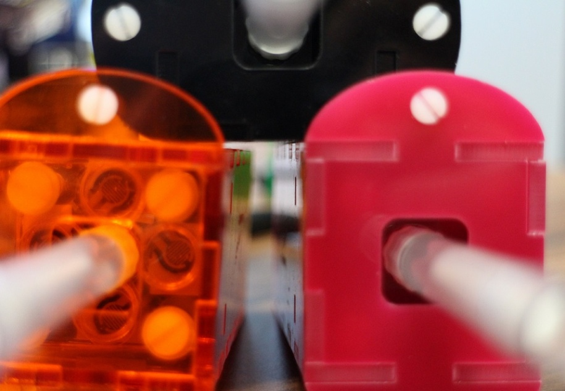

Written by:

Philipp Hauswirth, Raffael Šala, Jakob Wastl

Wien, 18.01.2016

Index

1 Partlist 3

2 Required tools 3

3 Building the FLipMouse 4

3.1 Gluing the acrylic case 4

3.2 Soldering the PCB 7

3.3 Assembly of the FSR/mouthpiece-carrier 13

3.4 Put all together 16

4 Testing 17

ANMERKUNG: Dieses Inhaltverzeichnis generiert sich selbst.

# Partlist

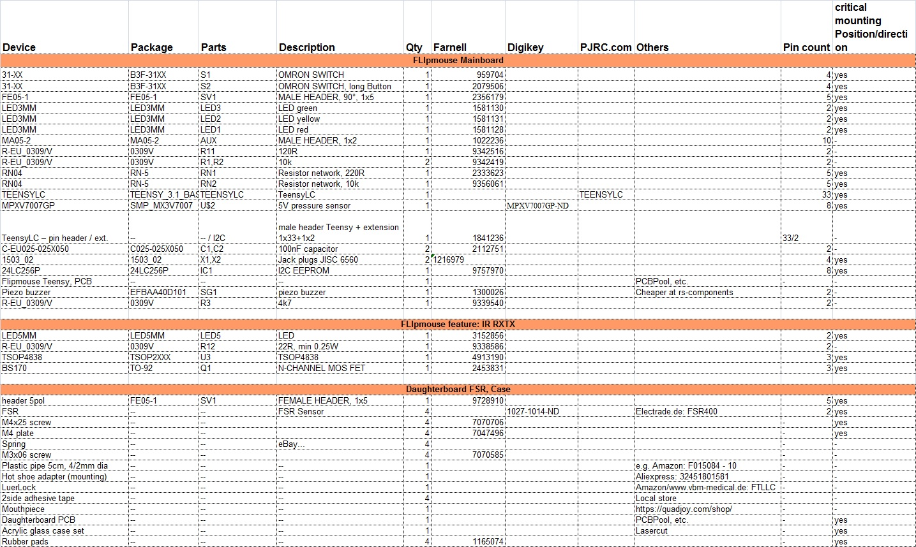

# Required tools

- Acrylic-glue

- Super-glue

- Soldering iron (small tip recommended)

- Wire-cutter

- Tweezers

- Flat-blade screwdriver

- Tapper/Thread cutter for M3 and M4

# Building the FLipMouse

In the next section you will find a step for step instruction to build the FLipMouse. It is recommended to hold on the correct order of these steps, to avoid any mistakes.

## 3.1 Gluing the acrylic case

Parts needed for this step:

- 1x Acryl: backplane

- 2x Acryl: side cover

- 1x Acryl: bottom cover

- 2x Acryl: mounting parts top cover

- 2x Acryl: mounting parts front cover

At first you have to position everything, like it is shown in the picture below. If done right, you can read the text “AsTeRiCs AcAdEmY” on the edges. The engrave should be on the top, except for the bottom piece.

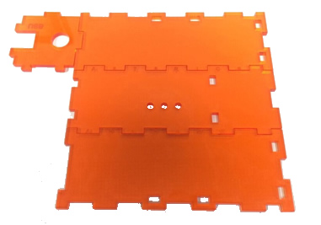

Now you can apply some glue to the yellow lines shown on the next picture. Take care for the “glue-strings”, because once the glue is on the acrylic plate, it is very hard to remove.

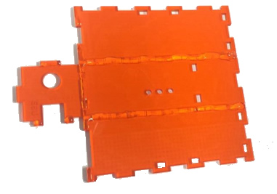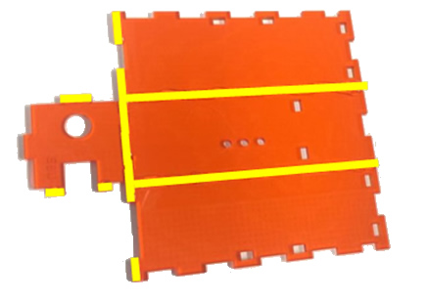

Fold and press the parts together and it is recommended to use the top cover as a distance keeper.

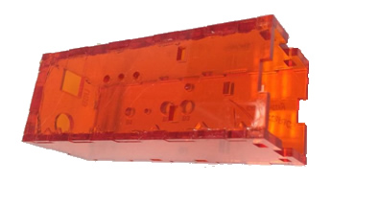

At next it is time to cut the M3 and M4 threads.

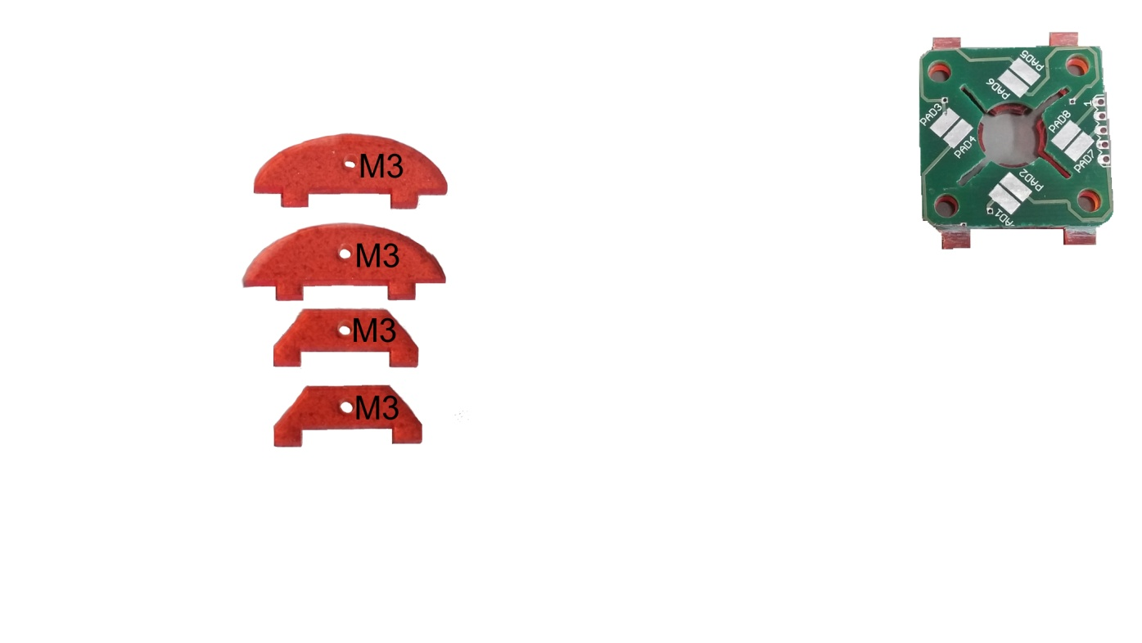 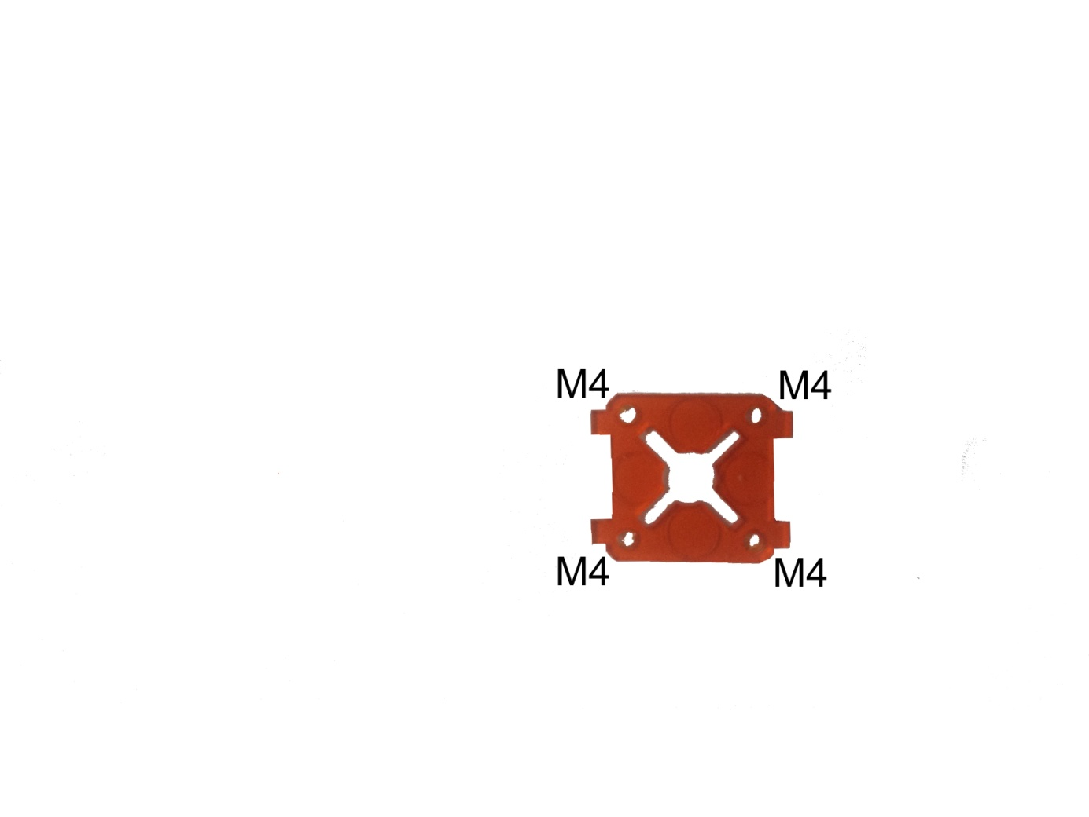

Now you can attach the 4 mounting parts with the M3 threads.

This time you don’t have to look for the correct side.

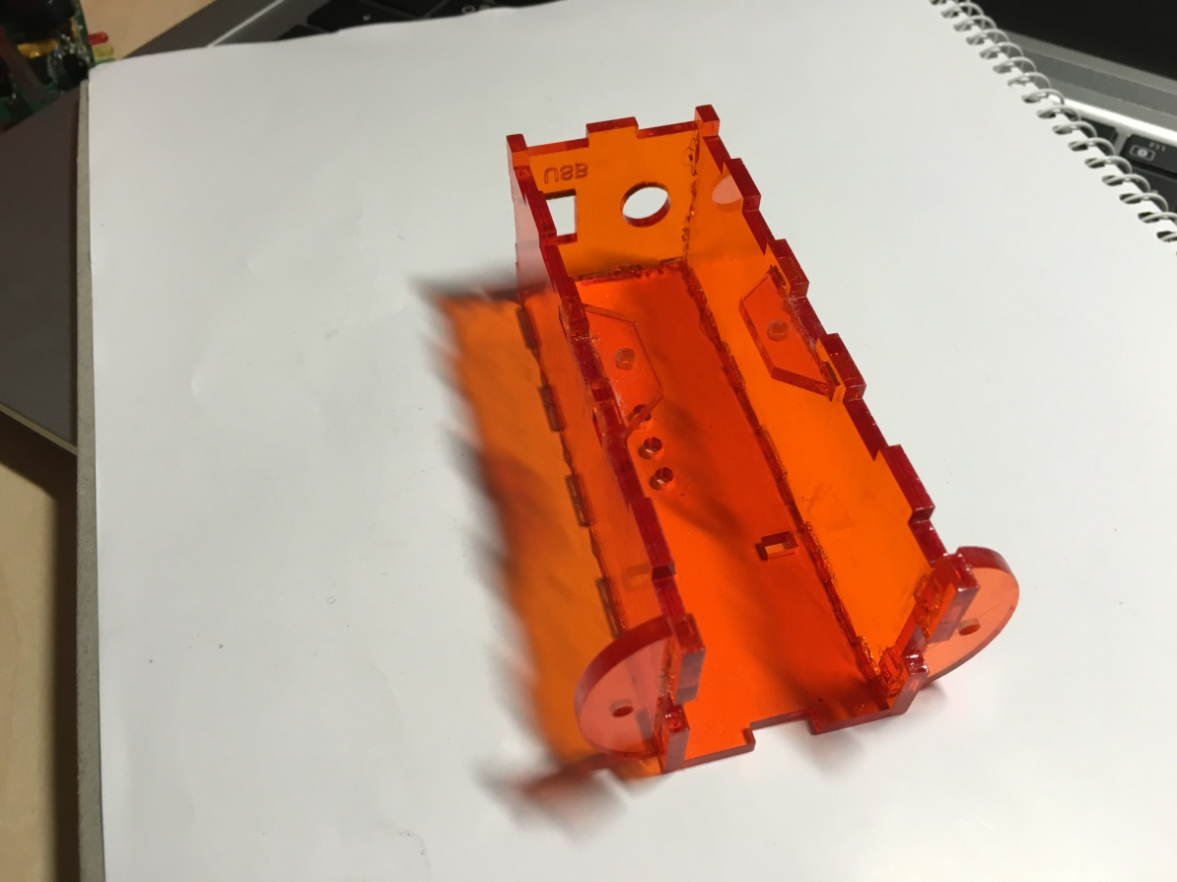

Let the glue dry for at least 1 hour. Afterwards you can install the front panel and the mouse mount.

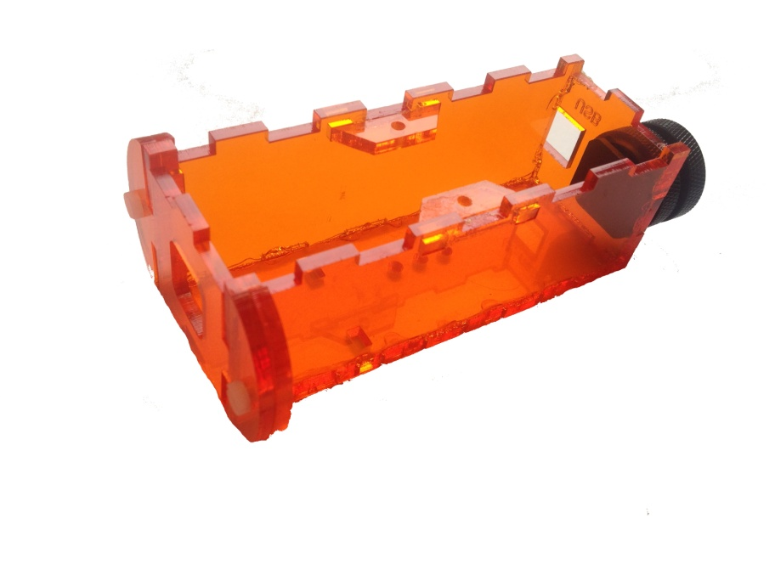

## 3.2 Soldering the PCB

The first step is to solder all pins to the Teensy.

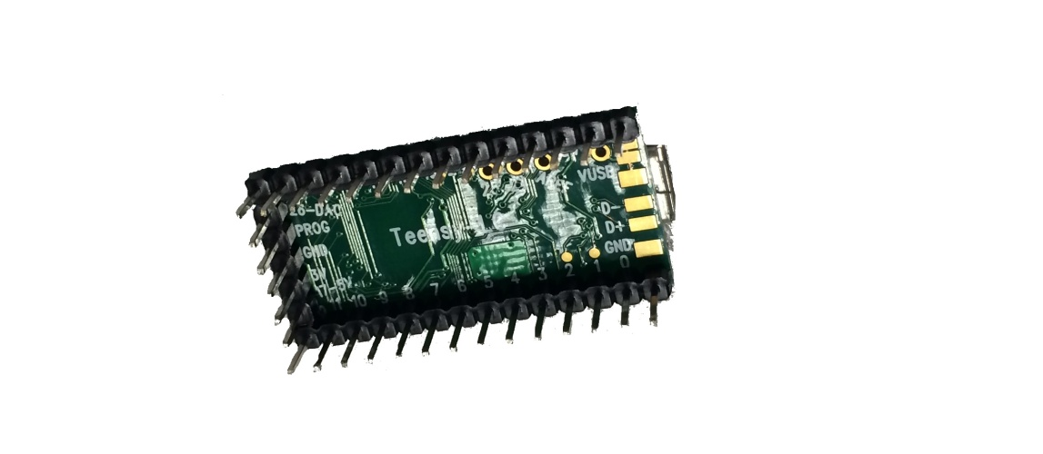

Here you have two pictures for reference where you can see how it should look like but follow the correct order below!

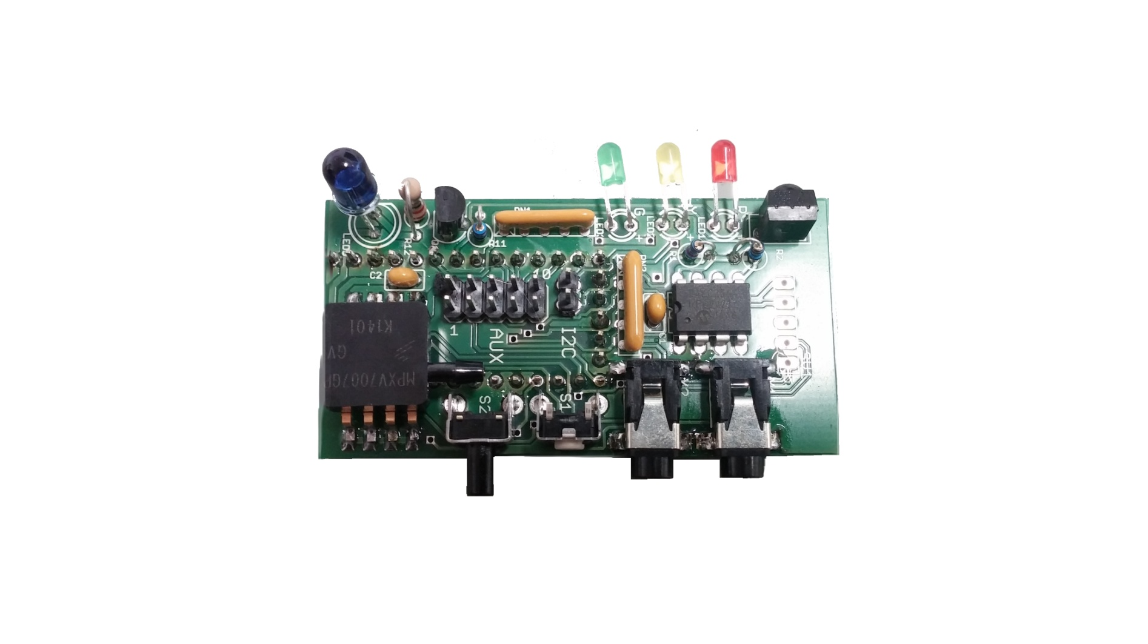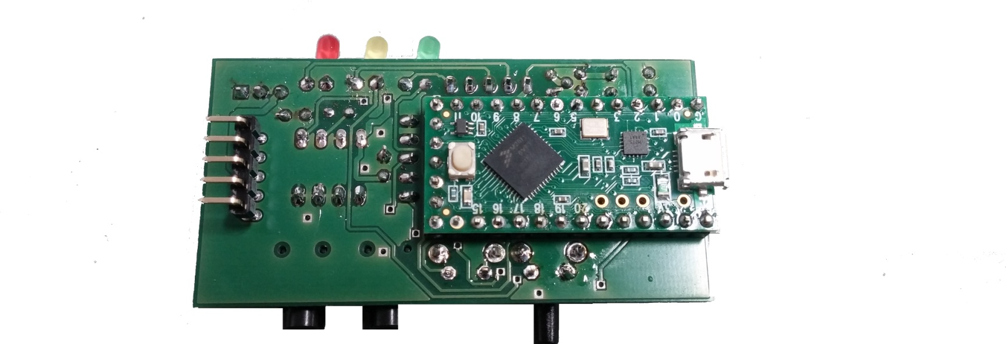

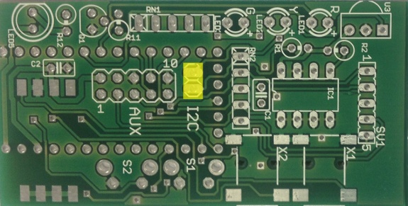 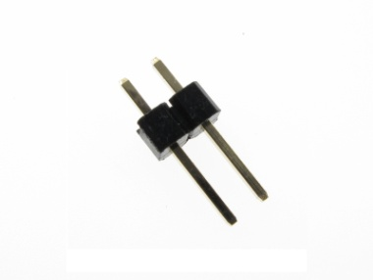

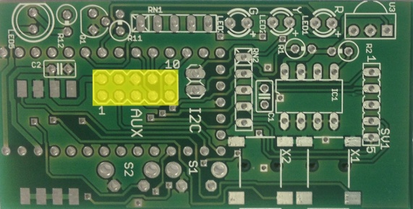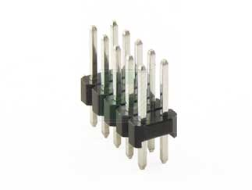

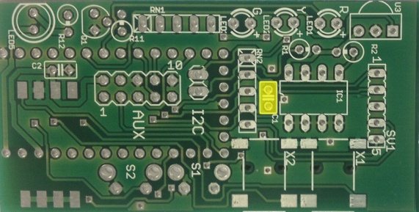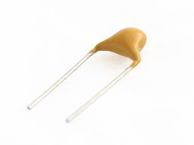

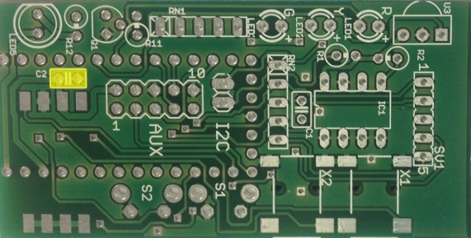

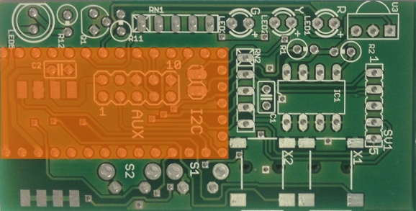

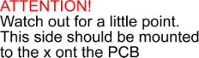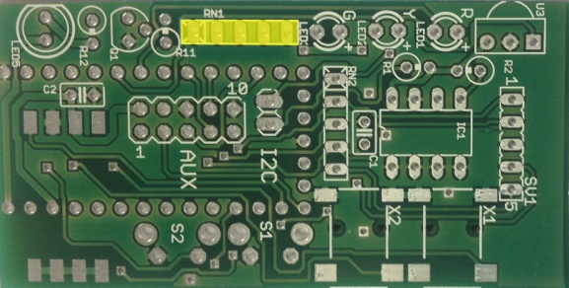 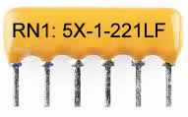

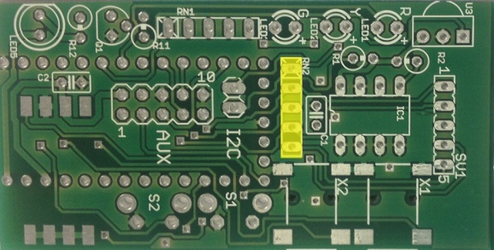 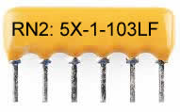

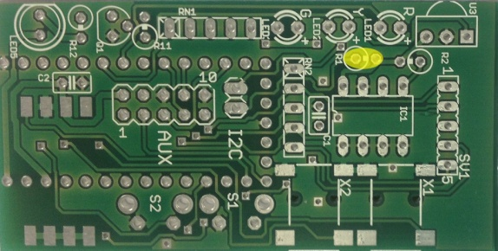 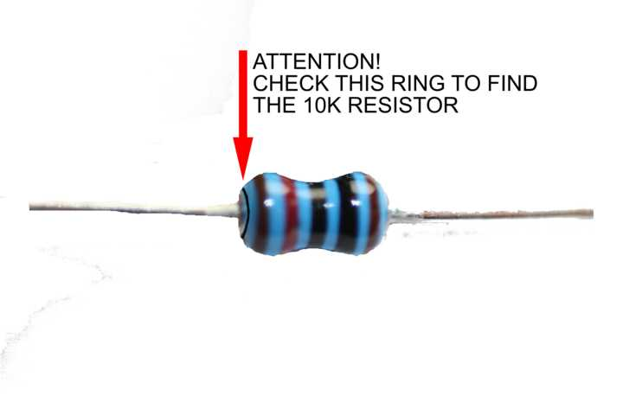

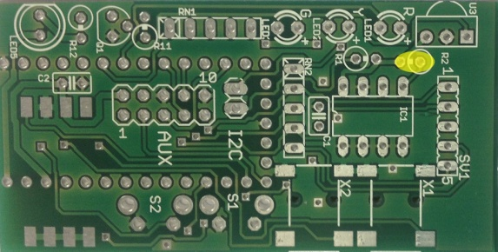 

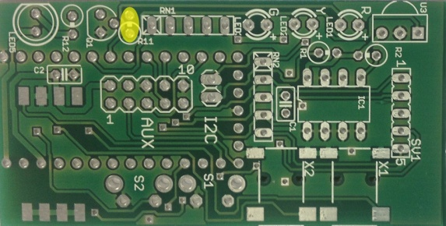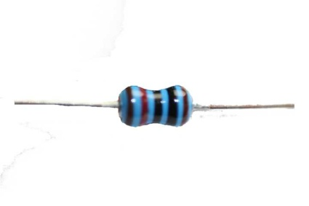

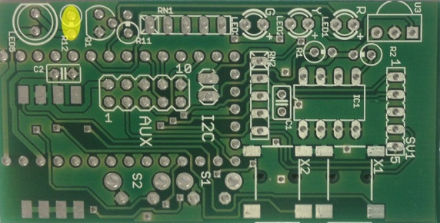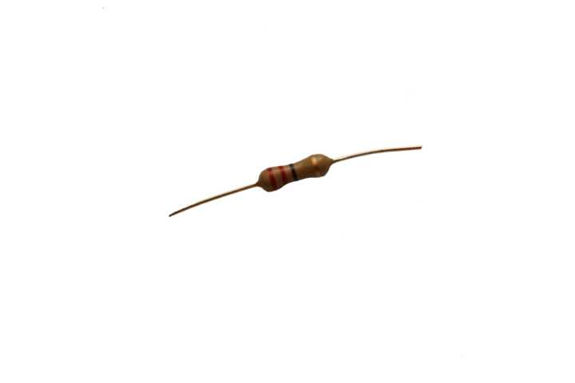

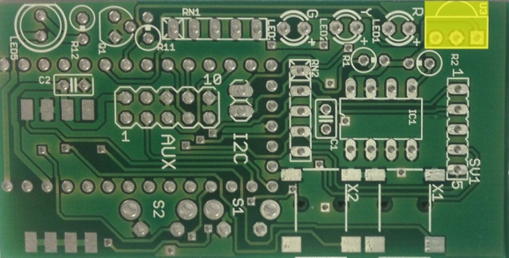 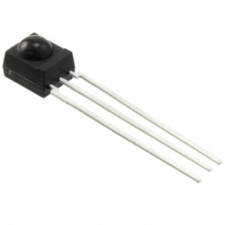

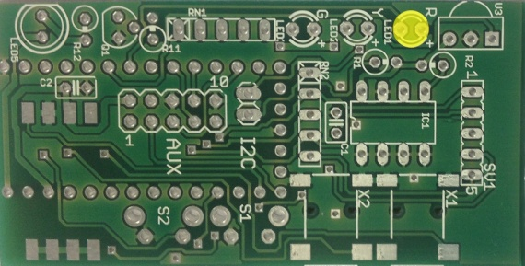 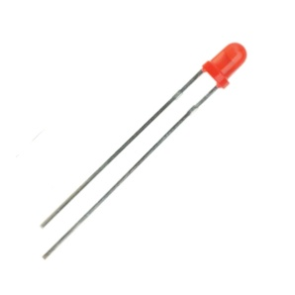

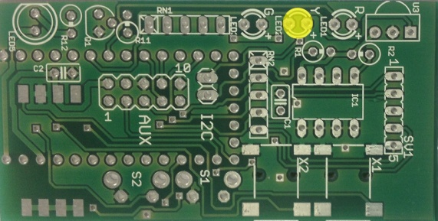 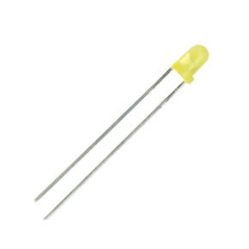

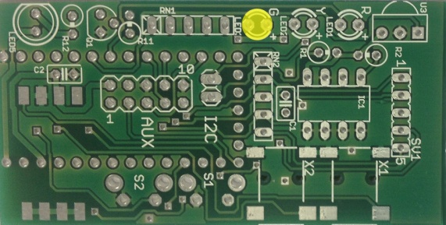 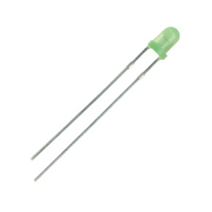

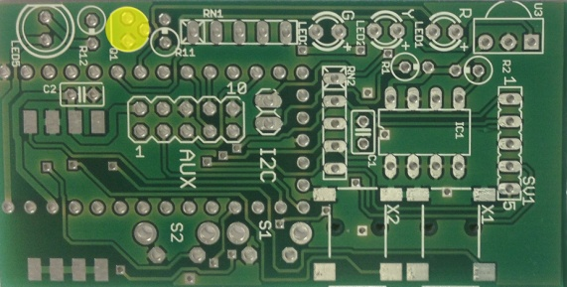 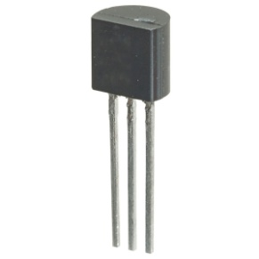

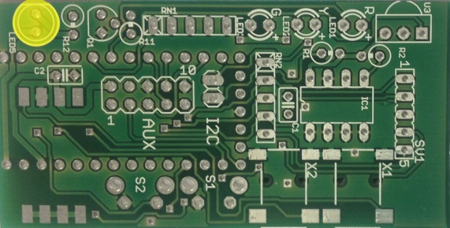 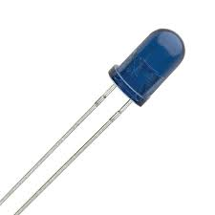

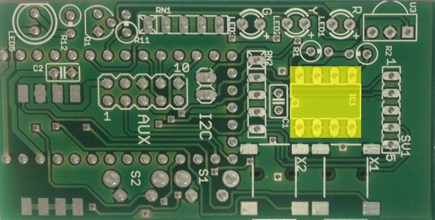 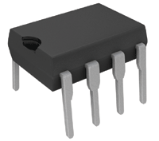

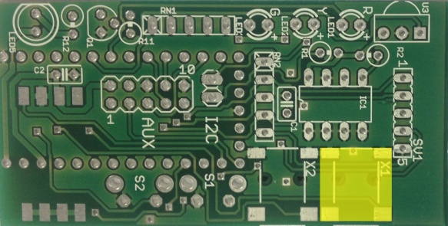 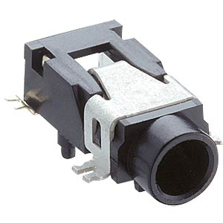

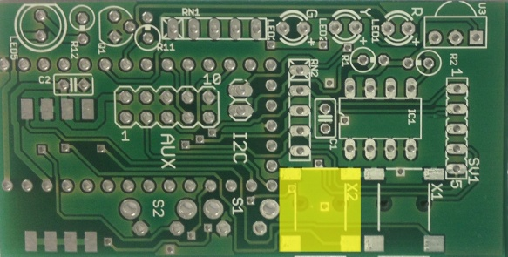 

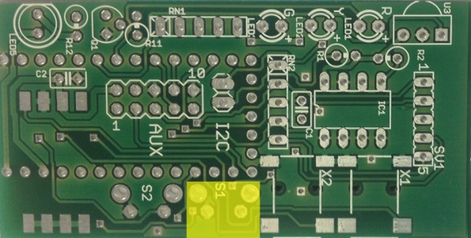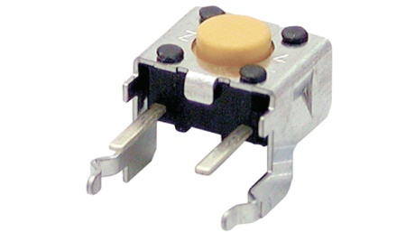

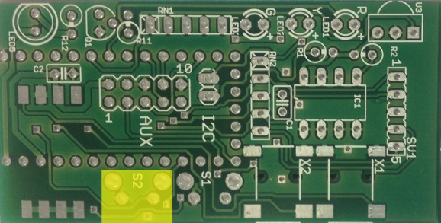 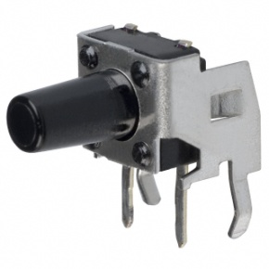

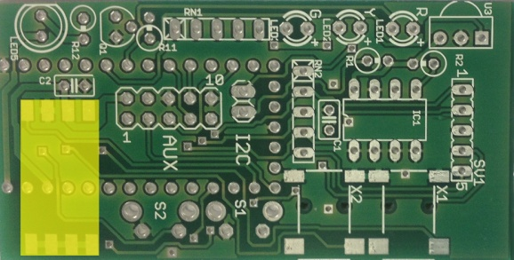 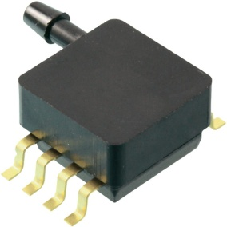

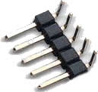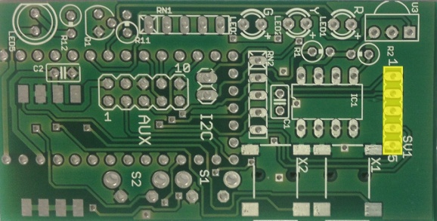 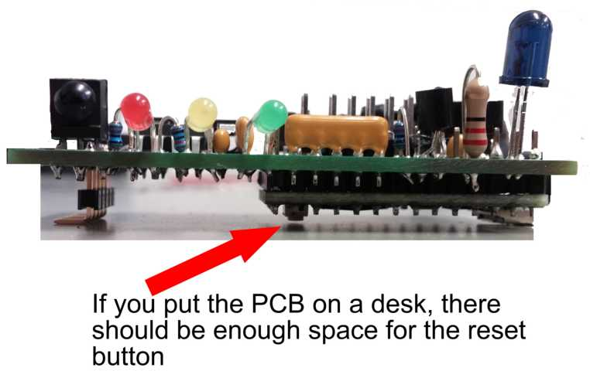

**OPTIONAL**: If you want acustic Feedback

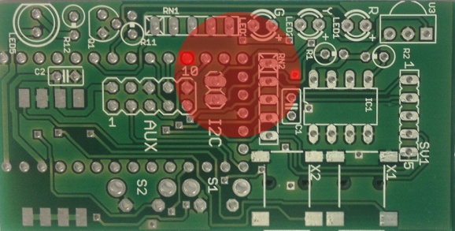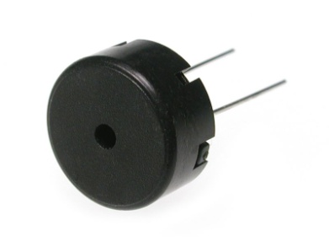

## 3.3 Assembly of the FSR/mouthpiece-carrier

## Glue the PCB on the acrylic plate with the X, so that solder points and the engraving is on the outside.

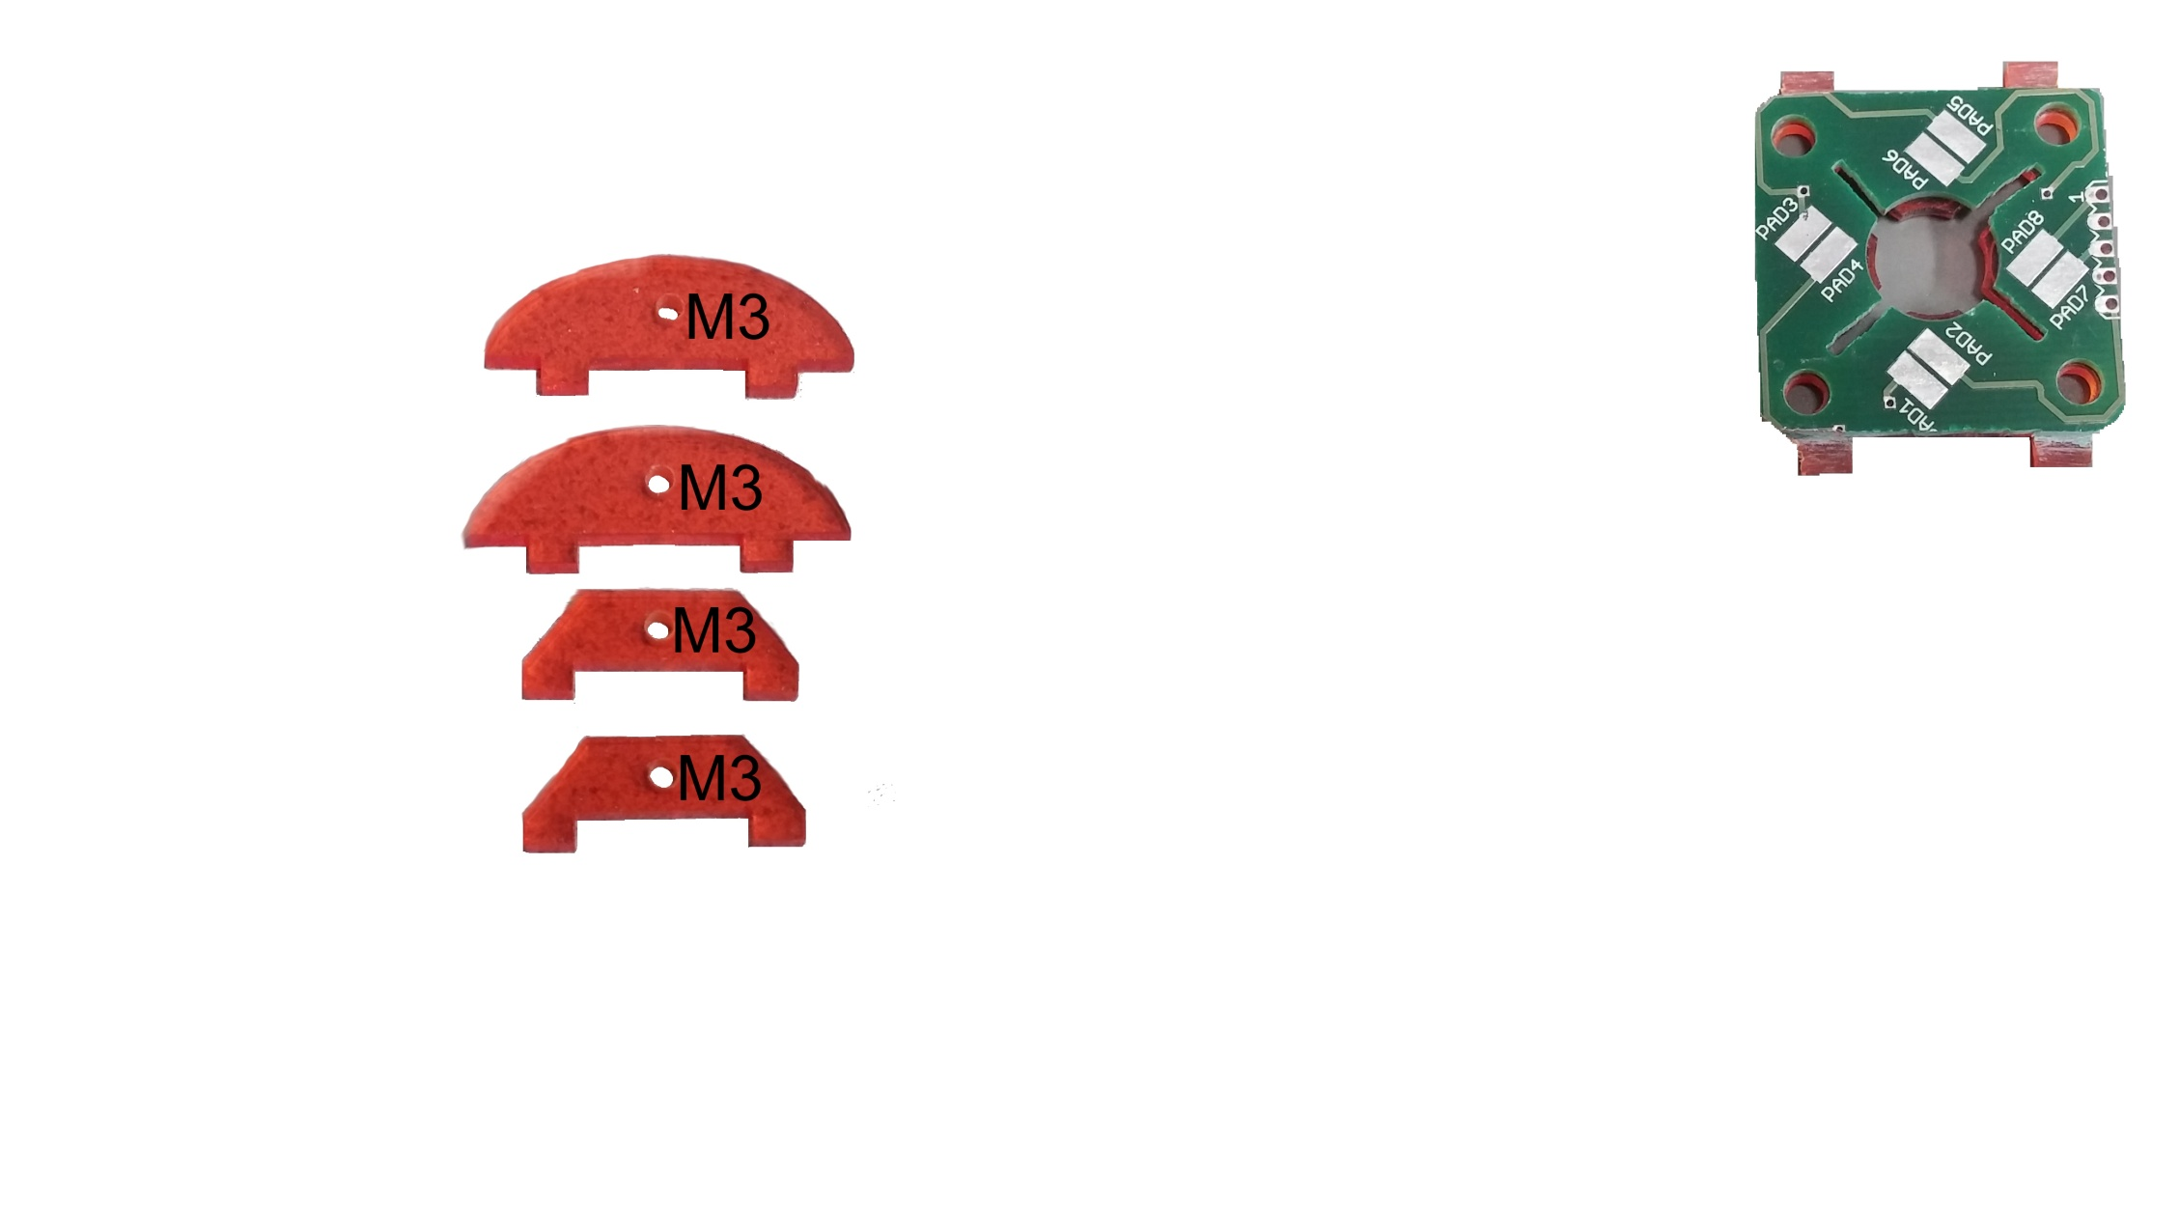

Solder the female headers as following

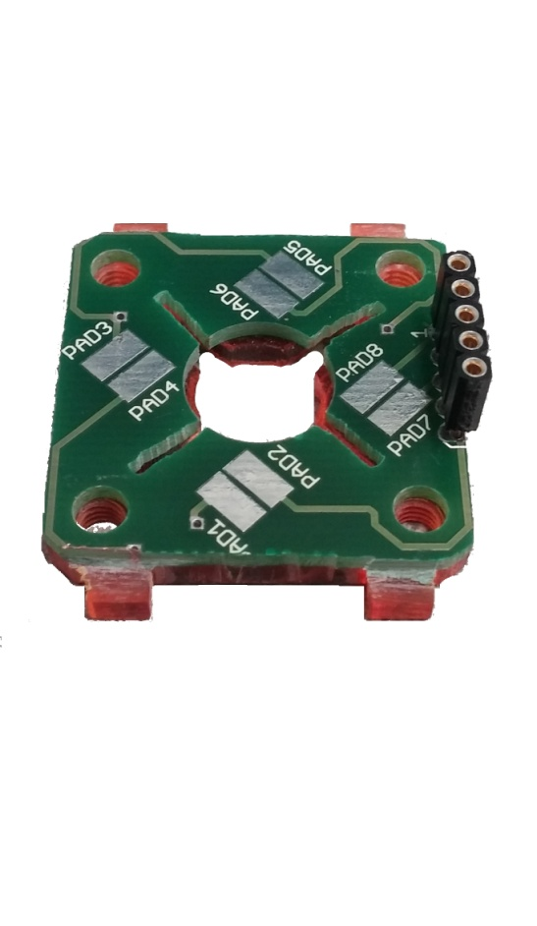

Now you can mount the FSR. You can use a double sided tape, but take care sometimes there is already a tape on the FSR.

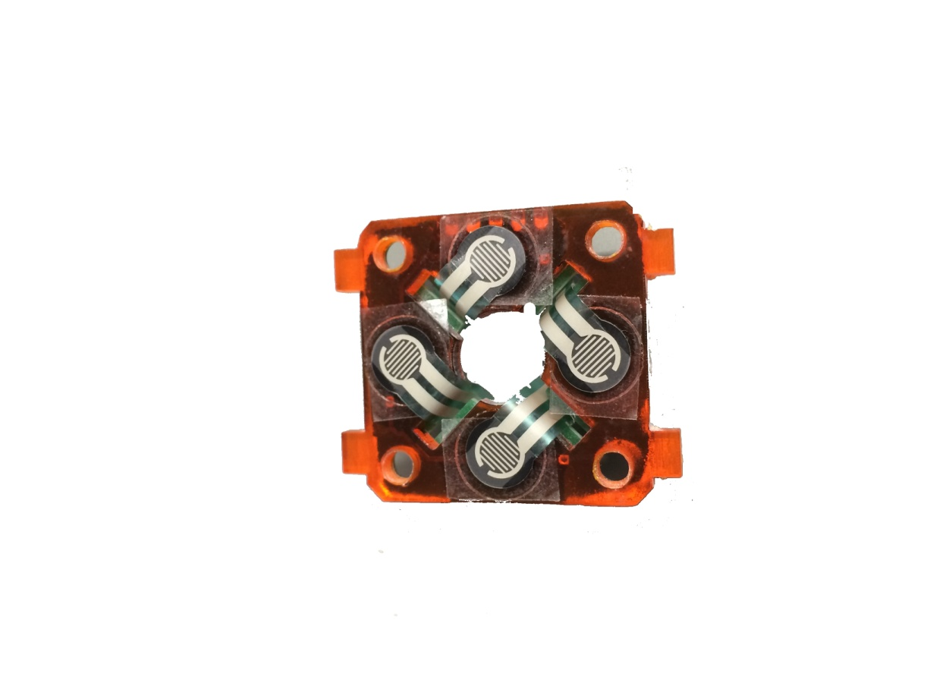

Solder the connections of the FSR on the solder-points of the PCB with care. The FSR should not get bend.

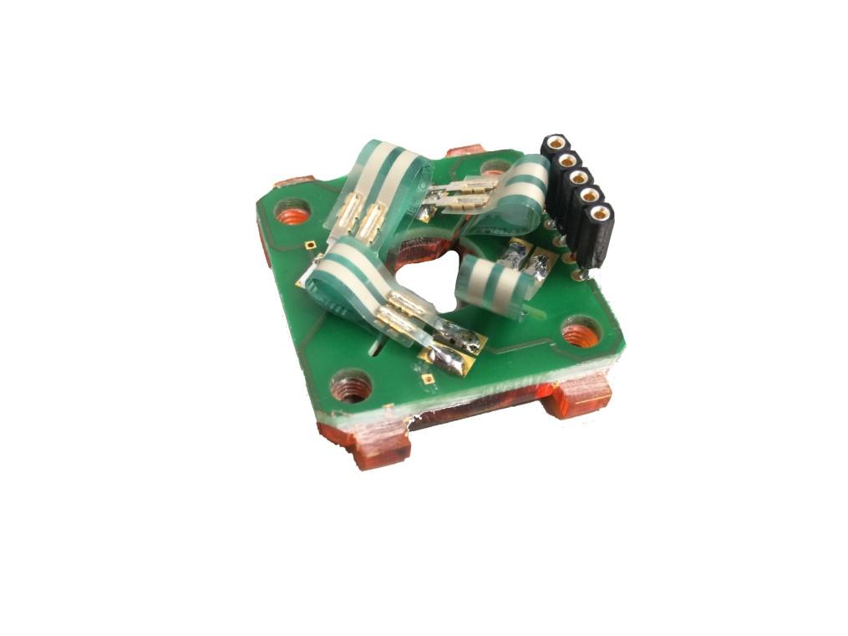

Glue the rubber pads on the other acryl front plate with the single hole on the engraved area and add the other parts

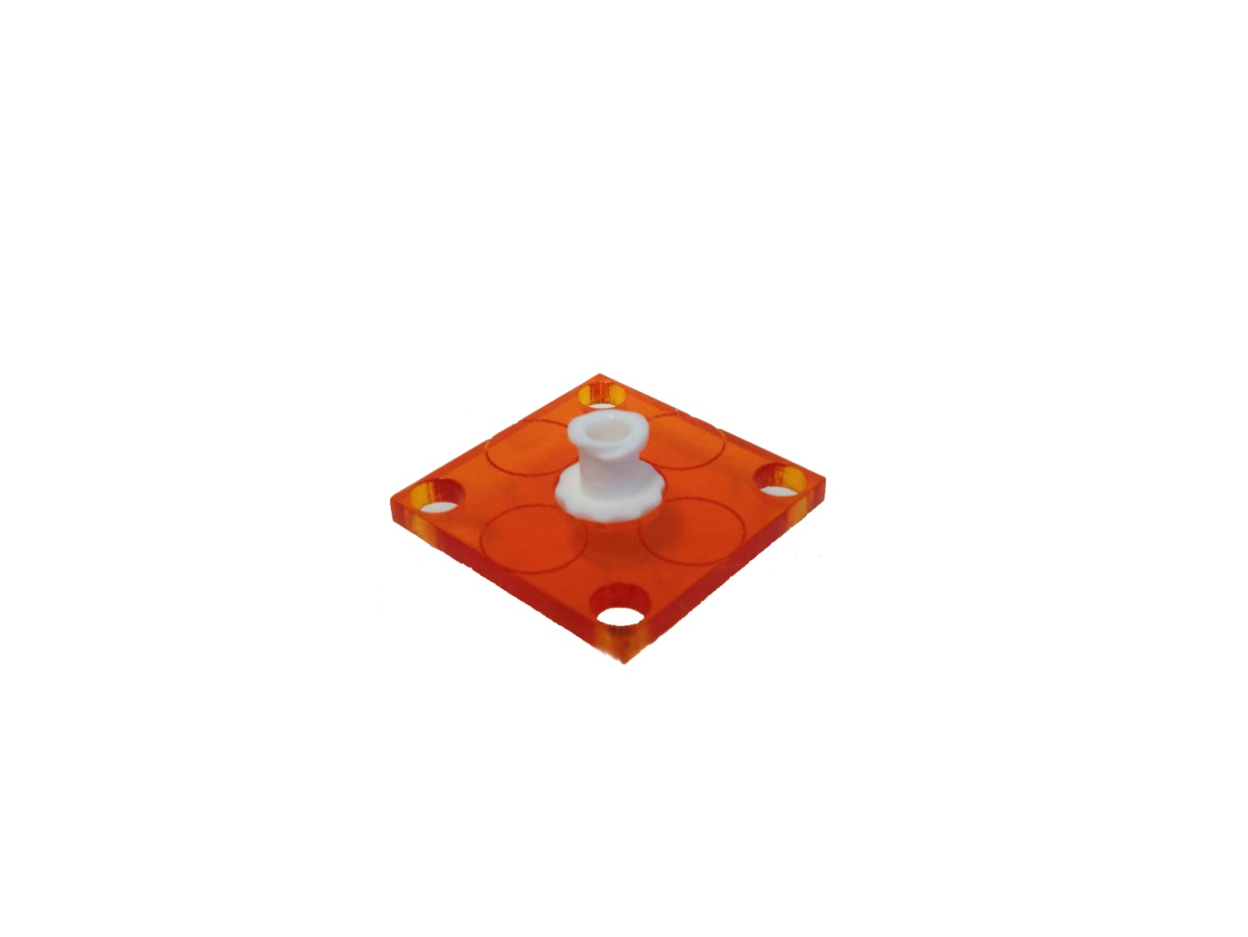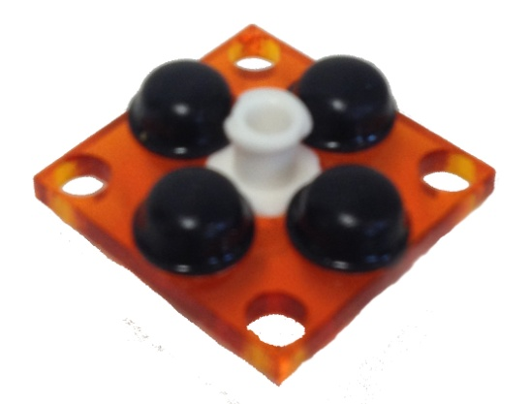

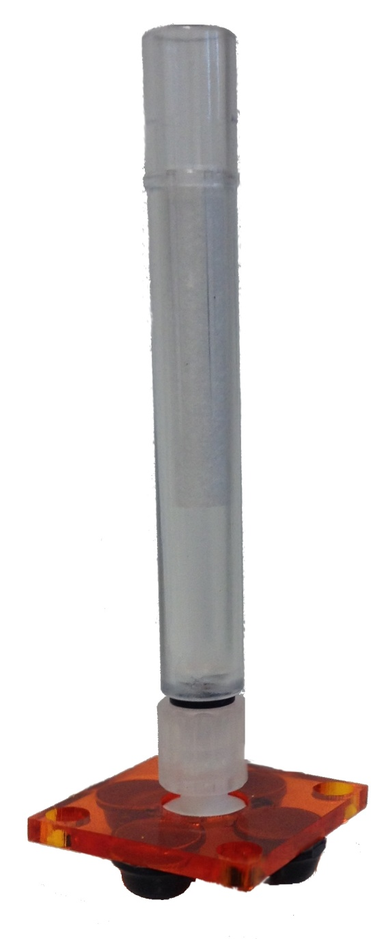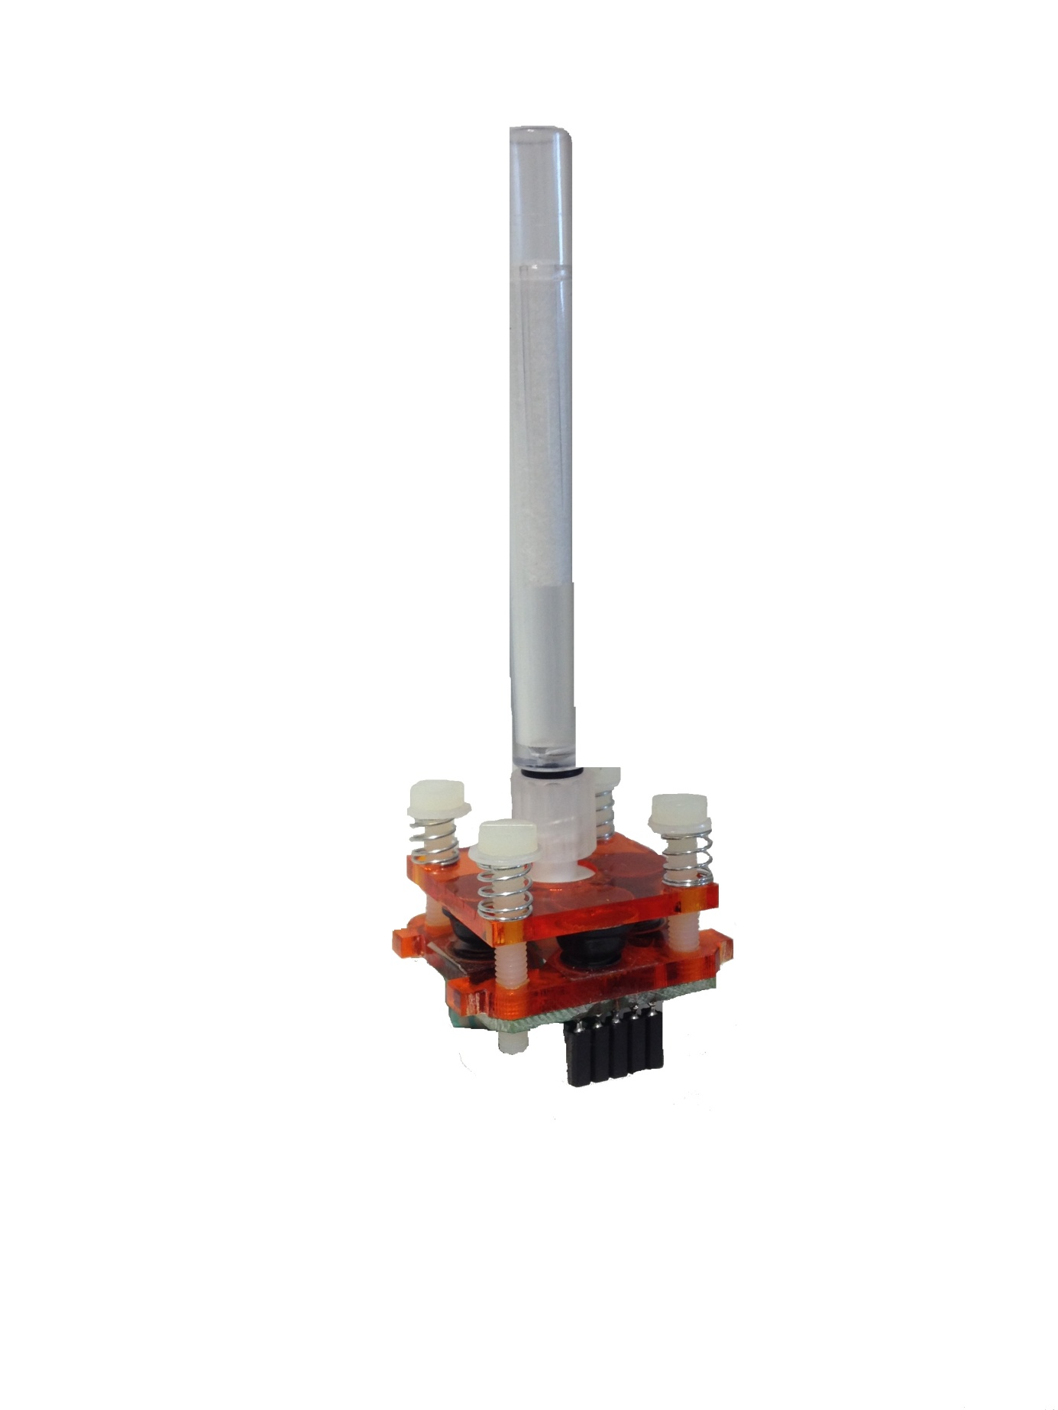

## 3.4 Put all together

At least mount the sip/puff hose, adjust the screws and put all together.

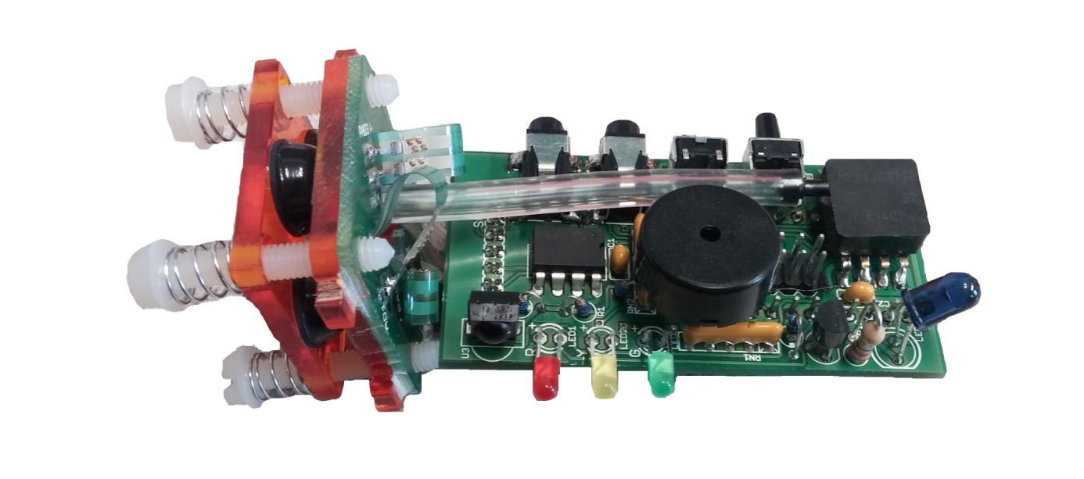

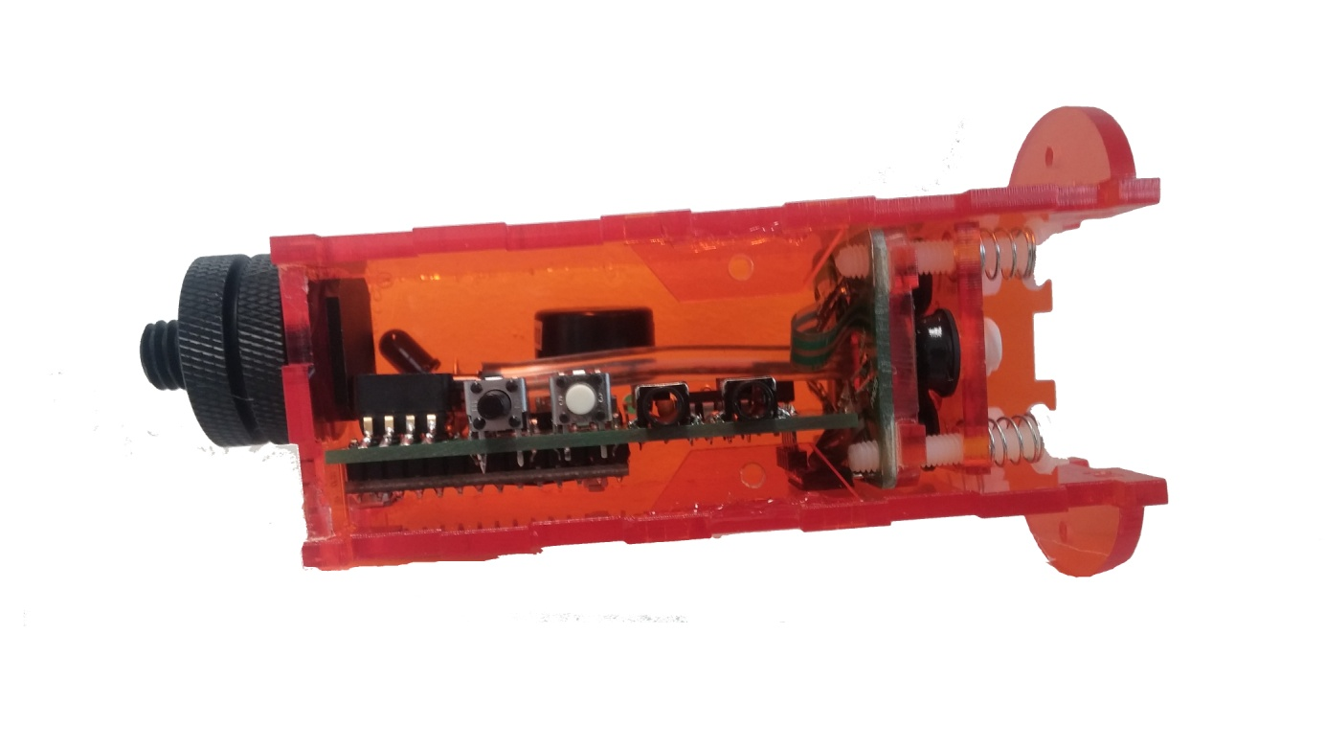

# Testing

Now it’s time to test it out. Connect the FLipMouse to the Arduino IDE and flash the Firmware. (FLipWare)

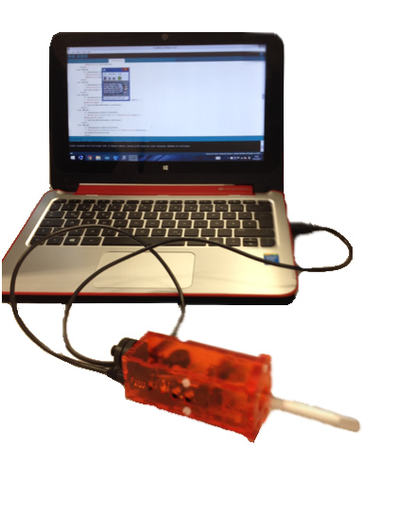

Now you could start the FLipMouseGUI.exe to check the Sensor Values. For the pressure sensor go to the Tab

“Sip Puff Levels”. The value should be in about that range as it is shown on the pictures. ­­If you get strange values double check the pins on the pressure sensor maybe there is to less solder.­

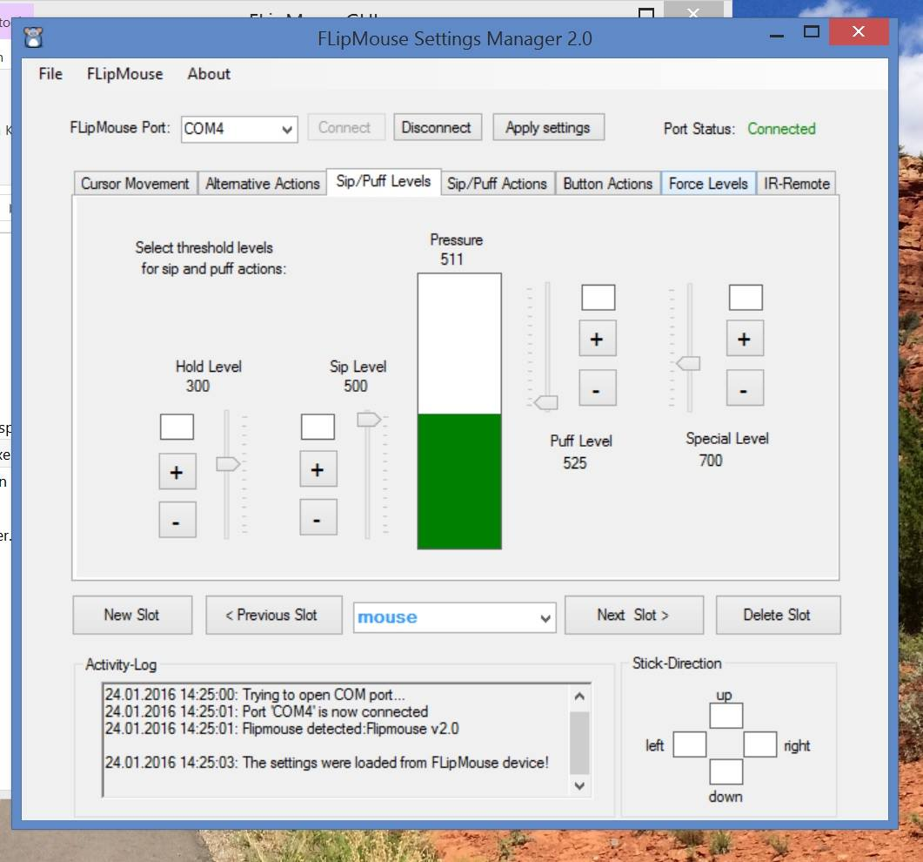

At least also check the FSR values in “Force Levels”.

For fine adjustment change the position of the mounting screws on the FSR daughter board.

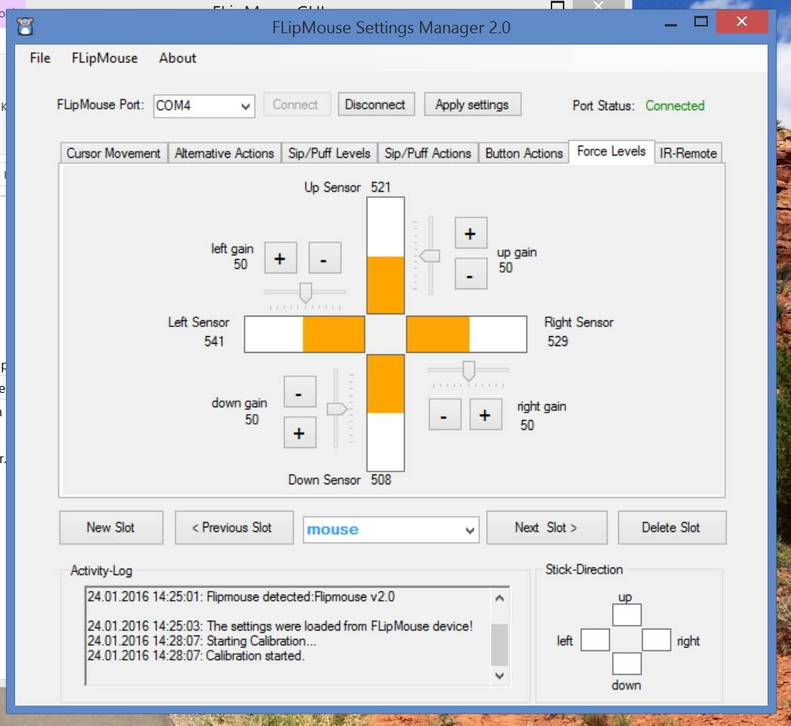

**­­HAVE FUN!**